Aim: - CIA Triad violation simulation using vulnerable web application.
Objective: -
- To understand the concept of the CIA Triad in information security.
- To simulate CIA Triad violations using a vulnerable web application.
- To demonstrate confidentiality, integrity, and availability attacks.
- To analyse the impact of security vulnerabilities on web applications.
- To study common web application vulnerabilities and their effects.
- To identify basic mitigation measures for preventing such attacks.

CIA Triad:
The CIA Triad is a fundamental security model in cyber security that consists of:
- Confidentiality
- Integrity
- Availability
A CIA Triad violation occurs when any one or more of these three security principles is compromised due to attacks, vulnerabilities, or system failures.

1. Confidentiality Violation
A confidentiality violation happens when unauthorized users gain access to sensitive information.
Examples:
- Data leakage through SQL Injection
- Password theft
- Unauthorized access to personal or financial data
Impact: Loss of privacy and exposure of confidential data.

2. Integrity Violation
An integrity violation occurs when data is altered, deleted, or manipulated without authorization.
Examples:
- Modifying database records
- Website defacement
- Tampering with user information
Impact: Data becomes inaccurate or untrustworthy.

3. Availability Violation
An availability violation occurs when authorized users are unable to access systems or data when required.
Examples:
- Denial of Service (DoS) attacks
- Server crashes
- Resource exhaustion attacks
Impact: Services become unavailable, causing downtime and operational loss.

SQL Injection:
SQL Injection is a web application attack in which an attacker inserts malicious SQL queries into input fields (like login forms or search boxes) to manipulate the database.
It happens when user input is not properly validated or sanitized.

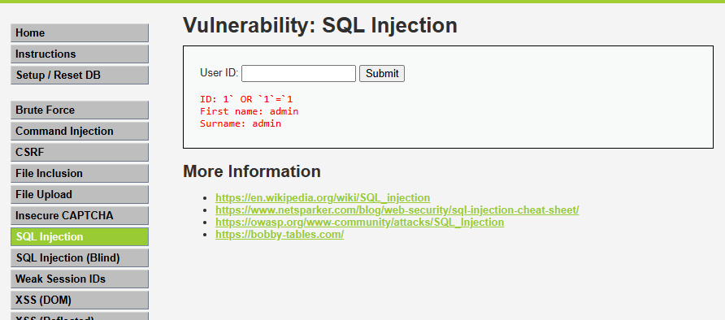

Brute Force:
Brute Force is a cyber-attack technique in which an attacker tries all possible combinations of usernames and passwords repeatedly until the correct credentials are found.
It relies on trial and error, not on intelligence or system flaws.

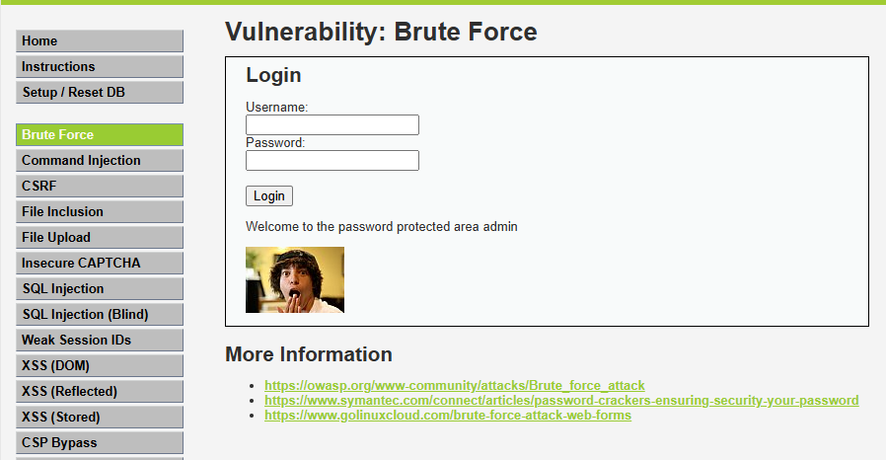

XSS (Stored):
Cross-Site Scripting (XSS) is a web security vulnerability in which an attacker injects malicious client-side scripts (usually JavaScript) into a trusted website.
When users visit the infected page, the script runs in their browser.

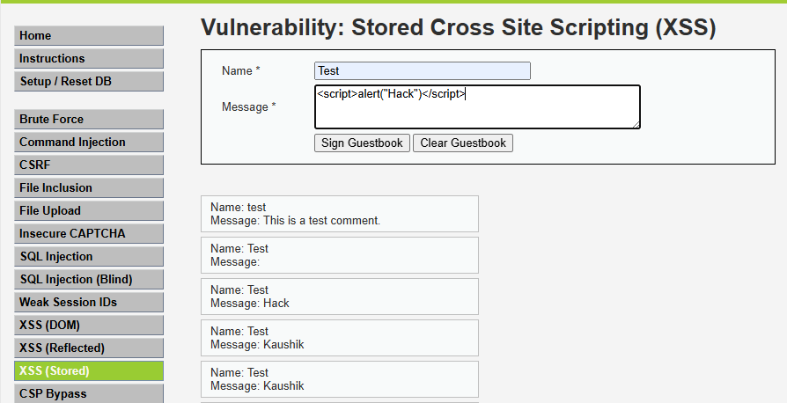
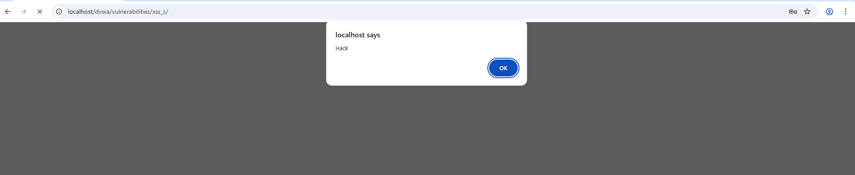

4. Command Injection:
Command Injection is a security vulnerability in which an attacker executes arbitrary operating system (OS) commands on a server by injecting malicious input into an application.
It occurs when an application passes user input directly to system commands without proper validation.

